**St. John, Christopher** **(1871-1960)**

Christabel Marshall, later Christopher St. John, studied at Somerville College in Oxford before moving to London, where she worked as a secretary to Lady Randolph Churchill while writing her first novel, *The Crimson Weed* (1900)*.* She was a fervent admirer of the British actress Ellen Terry, which led her to an eventual acquaintance with Terry’s daughter, the producer, director, designer, and actress Edith (Edy) Craig, with whom she spent nearly fifty years until Craig’s death in 1947. She changed her name to Christopher St. John after converting to Catholicism. Active in the suffrage movement, St. John played the role of the eighteenth-century cross-dressed soldier Hannah Snell in Cicely Hamilton’s *A Pageant of Great Women* (1909), and she and Hamilton co-wrote the popular suffrage comedy *How the Vote Was Won* (1909); both plays were directed by Craig*.* St. John also worked as a translator and playwright for Craig’s company the Pioneer Players (1911-1925), which staged her play *The First Actress* in 1911, a work that reinvented the suffrage pageant model by spotlighting the role of the actress and her centuries-long absence from the stage. St. John translated the tenth-century nun Hrotsvitha’s six plays into English for the first time; one of these, *Paphnutius*, was produced by the Pioneer Players in 1914, with Ellen Terry in the role of the Abbess. St. John assisted Terry as an editor on numerous projects, including a popular series of Shakespeare lectures; she and Craig also edited a revised version of Terry’s autobiography. St. John’s anonymous autobiographical novel *Hungerheart* was published in 1915, anticipating Radclyffe Hall’s *The Well of Loneliness* (1928) in articulating the central character’s passion for another woman. During World War I, Tony (Clare) Atwood, an artist who trained at the Slade School of Art, joined Craig and St. John as a third member of their household. Following Craig’s death, St. John and Atwood continued to support Craig’s commitment to the legacy of Ellen Terry through maintaining Smallhythe Place as the Ellen Terry Memorial Museum, now part of the National Trust. St. John’s involvement in suffrage drama and multi-faceted recuperation of women’s history places her work at the intersection of feminism and theatre in the early twentieth-century.

**List of Works:**

St. John, Christopher. (1900) *The Crimson Weed*, London: Duckworth.

----- (1959) *Ethel Smyth: A Biography*, with additional chapters by Vita Sackville-West and Kathleen Dale, London: Longmans, Green, and Co.

----- (N.d.) *The First Actress*, London: Utopia Press.

----- (1915) *Hungerheart: The Story of a Soul*, London: Methuen. (Published anonymously.)

----- (trans.) (1923) *The Plays of Roswitha*, London: Chatto & Windus.

Hamilton, Cecily, and Christopher St. John. (1985) *How the Vote Was Won*, in *How the Vote Was Won and Other Suffragette Plays*, ed. Carole Hayman and Dale Spender, London: Methuen, 1985, 21-33.

**References and Further Reading**

Adlard, Eleanor, ed. (1949) *Edy: Recollections of Edith Craig*, London: Frederick Muller.

Cockin, Katherine. (1998) *Edith Craig (1869-1947): Dramatic Lives*, London: Cassell.

Cockin, Katherine. (2001) *Women and Theatre in the Age of Suffrage: The Pioneer Players, 1911-1925*, London: Palgrave.

Holroyd, Michael. (2008) *A Strange Eventful History: The Dramatic Lives of Ellen Terry, Henry Irving and their Remarkable Families*, London: Chatto & Windus.

Craig, Edith, and Christopher St. John. (eds.) (1932) *Ellen Terry’s Memoirs*, New York: G. P. Putnam’s Sons.

Rachlin, Ann. (2011) *Edy Was a Lady*, Leicester, UK: Matador.

**Lesley Ferris, The Ohio State University**

**Recommended Illustrations**

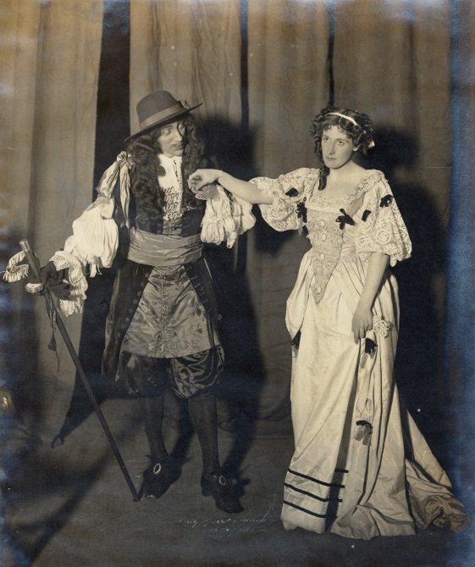

**The Pioneer Players production of *The First Actress* by Christopher St. John, Kingsway Theatre, London, 1911.**

[Available at: <http://www.vam.ac.uk/content/articles/p/political-theatre-in-the-early-20th-century/> ]

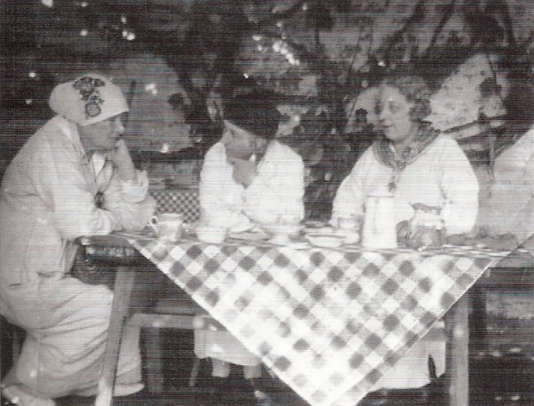

**From left to right: Edith Craig, Clare Atwood, and Christopher St. John at Smallhythe Place, circa 1920.**

[Available at: <http://en.wikipedia.org/wiki/Christabel_Marshall> ]